**Notification Project Phase One**

* NotificationV2 Folder
* NotificationV2/ deliverables/Standard/6.0.0/ - includes all the build files
* NotificationV2/res/ - includes all the image that used in the application
* NotificationV2/src/mainPackage – includes all the java class files
* NotificationV2/bin/mainPackage – classes are separated
* NotificationV2/src/mainPackage
* IntroScreen.java includes:

1. IntroScreen class (UiApplication)
2. TopScreen class (MainScreen)
3. InformationScreen class (MainScreen)
4. savedInformationScreen class (MainScreen)

* SubScreen.java includes:

1. HomeScreen class (MainScreen)
2. FindScreen class (MainScreen)
3. SearchScreen class (MainScreen)
4. FavoriteScreen class (MainScreen)
5. FilteredProgramScreen class (MainScreen)

* FavouriteItem.java includes:

1. FavouriteItem class (Persist Object)

* CustomClasses.java includes:

1. CusomButtonField class (Field)
2. JsonParsing class
3. Program class (Object)
4. ToolMethod class

* VerticalButtonFieldSet.java includes:

1. FieldDimensionUtilities class
2. HorizontalButtonFieldSet class(Manager)
3. VerticalButtonFieldSet class (Manager)

* VerticalScrollManager.java includes:

1. VerticalScrollManager class (VerticalFieldManager)

* PersistentStoreListener.java includes:

1. PersistentStoreListener class

* 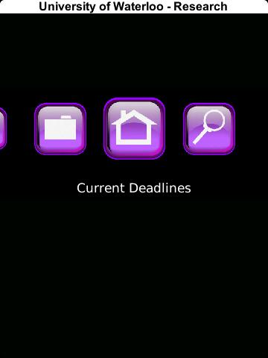Application Screens & Link Flow

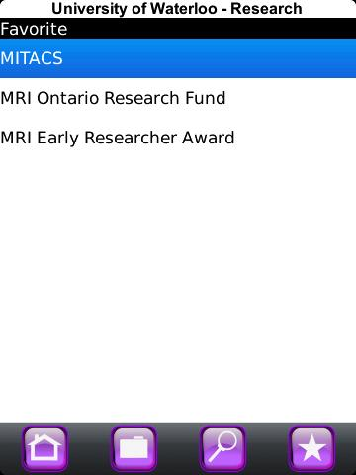

FavoriteScreen

TopScreen

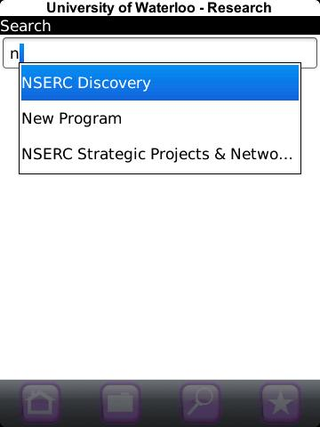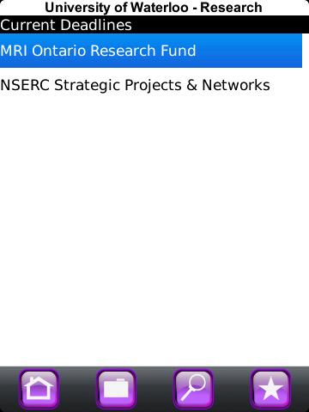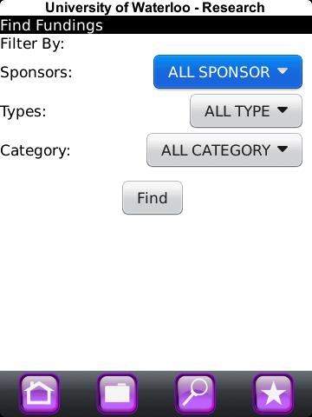

SearchScreen

FindScreen

HomeScreen

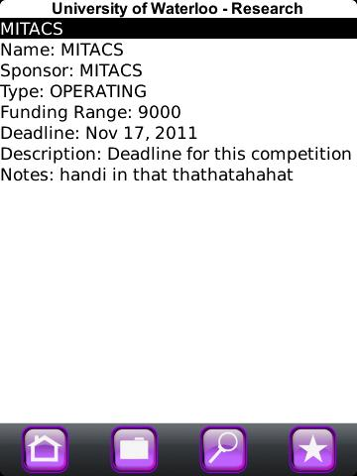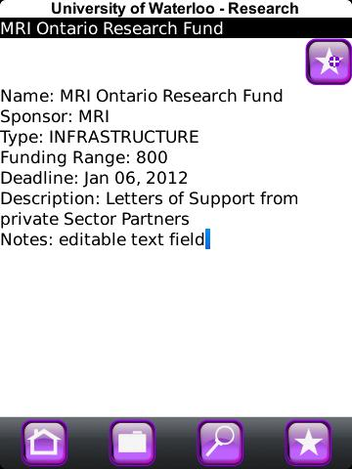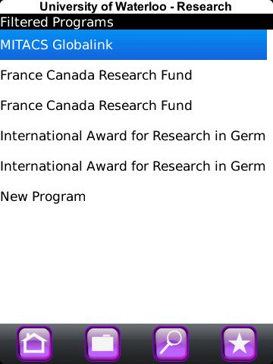

FilteredScreen

SavedInformationScreen

InformationScreen